Trivago Redesign

Written by Group 7

1. **Introduction to Problem**

Trivago is a travel site that allows users to compare prices between several different websites to determine a best price from among them. However, while this service is wonderful, the website is not. After analyzing the website, our group has found several issues that need to be addressed. Some of these issues included having poor backgrounds, an unclear price filter, and hidden information behind hotel cards. The backgrounds and overall aesthetic needed a definitive update as there was too much white space and poor contrast ratios that hampers the site as a whole. A more specific issue with the site is the price filter, as it is rigid in its design while being unclear in its range. Problems such as these can lead to a poor user experience and provide less business for the Trivago brand.

1. **Redesign (first design)**

There are 4 pages to the Trivago website, and changes were made to each one. The page with the fewest amount of changes was the menu page. We only changed the background color of this page from white to a dark blue. The reason we did this was because we felt the previous white background was really bright and made the viewing of the page unpleasant. This change was made throughout all of the web pages of the site.

The next page changed was the login page. This page’s layout was changed slightly to better conform with the user’s reading flow. Specifically the “Sign In With” options were moved from the side of the login to directly below it, as seen in the figures below.

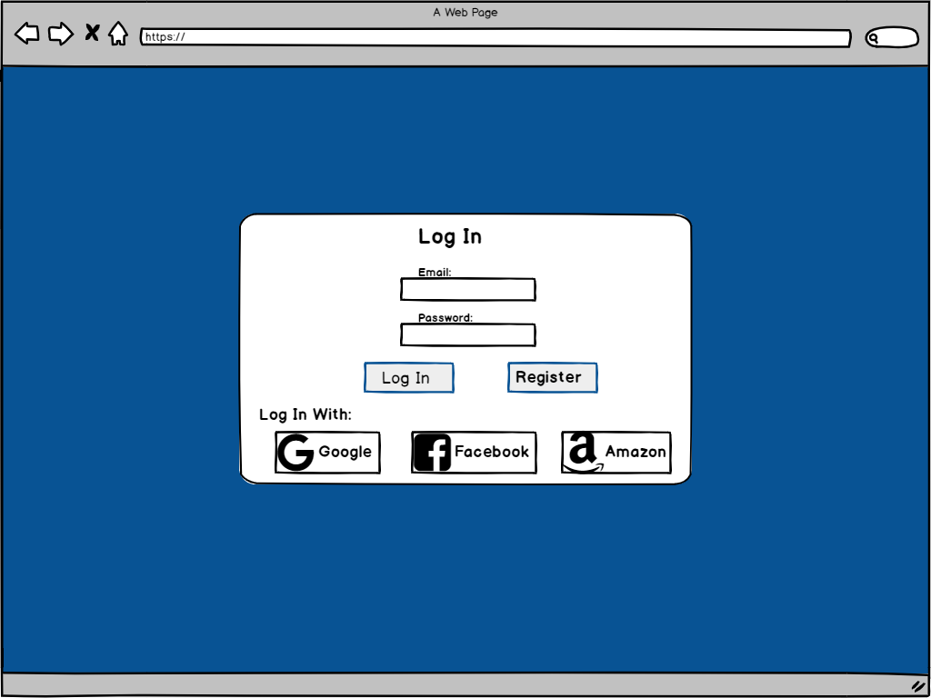

*Figure 2.1 Trivago Wireframe*

The most changed page was the search result page. Most of the changes on this page occured to the different search filters offered by the website. The first filter change happened to the price filter. The original price filter was just a slider with a minimum value of 60 and a maximum value of 400+, with no way to type an input. We did not like this because it provided low usability to the web goer. We replaced this with a slider with 2 heads that created a range of prices, where you could optionally input the prices instead of sliding. This helpful because it gives the user more control over there search and makes it easier to use. Another change came to the accommodation filter. Originally when the user was selecting they’re style of commendation they had to choose a range from 5 star down to whatever they chose. We found this restricting to the user, so we changed the filter to allow them to choose precisely what kind of hotels they would like to stay, not restricting them to a range. The final change made to the search result page was done to the layout of the page. Essentially the original website wasted a lot of space by having a single column of hotel cards with a lot of empty space to both sides, we reduced this by creating to columns, which better utilized the space and created less of a need for scrolling. You can see all of our changes to the result page reflected in the figure below.

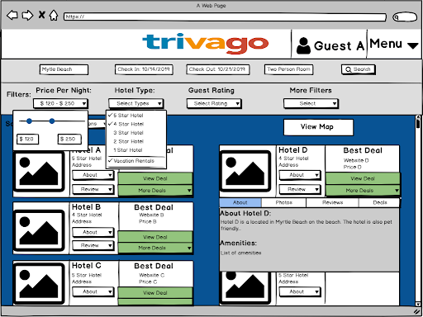

*Figure 2.2 Our Original Wireframe*

The final page of the redesign was the Search Page. Besides the changing of the background color there was only one significant change to the search page. In the original webpage there were a bunch of Trivago magazine ads at the bottom of this page. These adds don’t help the user at all, and try to distract them from the functionality of the website. Therefore we removed these images from the page.

1. **Evaluation Methods & Results**
2. Introduction to Evaluation Methods and Results

In order to not just improve the original Trivago website, but also perfect our own first attempt at a redesign, multiple methods of peer evaluation had to be utilized. These analyses served as a way for us to better understand what a typical consumer desired from our site. Each type of evaluation highlighted specific aspects of the site for participants to weigh in on; the survey supplied us with feedback on our style choices and told us what functions were most important to users, the card sorting helped us to determine how to arrange the numerous filters associated with hotel searching, and the heuristic evaluation allowed us to interpret the severity of our existing usability flaws. By setting up multiple evaluations, each with their own focus area, we were able to collect more valuable and beneficial data to bring new insights to our group about how to improve the site and create a more user-friendly interface.

1. Interpreting the Survey Results

As previously stated, the primary objectives of our survey were to 1) gather feedback on our first-stage redesign and 2) determine the functions most important to potential consumers. In order to achieve these two goals, we constructed a survey based on Fred Davis’ Technology Acceptance Model (TAM). Davis’ (1989) original TAM explained that the user’s acceptance of a new technology (in our case, the redesign of Trivago) is based on two factors: the user’s perceived usefulness (PU) and their perceived ease of use (PEOU). Davis defined the former of these two terms as “the degree to which a person believes that using a particular system would enhance his or her job performance” (‘job performance’ refers to task at hand) and the latter as "the degree to which a person believes that using a particular system would be free of effort” (Davis, 1989, p. 320). By associating objective 1 (gather feedback on the redesign) with PEOU and objective 2 (determining important functions) with PU, we were able to gather valuable and actionable feedback.

The survey consisted of 10 questions including open-ended, open response-option, closed-response, and likert scale type questions. The first few questions were open-response option and closed-response type questions that dealt with the functionality of the site. When asked what the most important factor in choosing a hotel was, 75% of participants responded that customer reviews were the priority, while 25% chose quality (star rating) of hotel. Both of these filters existed in their own menu outside the larger list of search parameters in our first-stage prototype. When asked what affects a user’s decision on the location of their hotel the most, the answers were split 50/50 between nearby activities and price per night. Both of these filters also existed in our first-stage prototype. This data can be interpreted as a high PU of the users who took the survey. It wasn’t until we introduced an image of our prototype and open-response questions that we could begin to see the users’ PEOU.

The final questions were open-response questions with dealt primarily with the design and layout of information of our search results page. When asked what the user liked best about the layout, 75% of participants referenced the easy to navigate and uncluttered feel of the site. When asked what they liked least, another 75% mentioned that either the color scheme or font. Interpreting this data, we realized that for as strong as they felt about the PEOU, they felt just as strong about the need for a visual revamp.

After interpreting all the data collected from our survey, very few changes were made to the layout of information on our website. However, a large overhaul of the interface design took place. From the first wireframe, shown in *Figure 2.2*, to the final prototype, shown in *Figure 3.3*, the dark blue background has been replaced with a lighter, more appealing shade and we increased the size of almost all text boxes, fonts, and icons that were hard to see or interpret.

1. Interpreting the Heuristic Evaluation Results

We conducted a Heuristic Evaluation with three participants from our class. Based on their feedback, there were nine issues with high severity. We decided to focus on these nine problems first, and then work on lower rated issues if time allotted. In total, we were able to fix or improve 11 problems noted by the participants.

The major issues participants had with our prototype were the background color, search bar functionality, too many options on hotel cards, and hotel information covering the next hotel card. For the background color, we adjusted the shade of blue used so it was lighter and more pleasing to the user’s eyes, according to Tom Osborne’s *Color Contrast for Better Readability*. 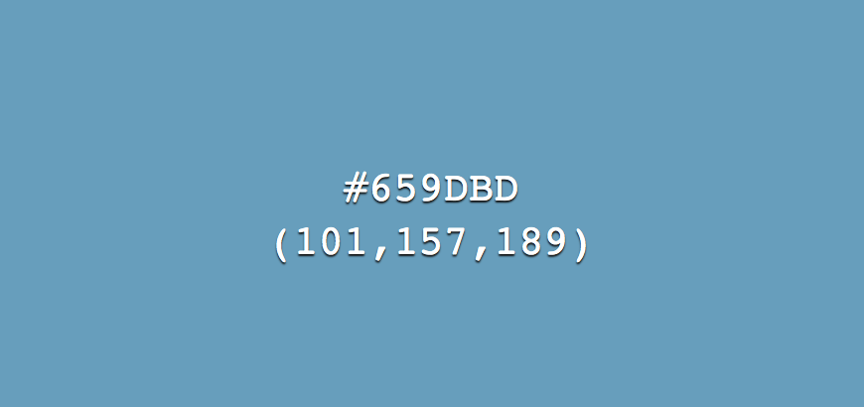

*Figure 3.1 Our Trivago redesign background color*

In regards to the hotel cards, we improved the simplicity and overall aesthetics by reducing the number of buttons for additional information about each hotel. Our original wireframes, shown in *Figure .2*, include four buttons, three of which are for more details about the hotel. Based on feedback from the heuristic evaluations, we decided to reduce the three detail buttons down to one “more info” button that opens a panel with tabs for each category that originally had separate buttons. No information was lost in this improvement, as you can see in *Figure 3.3*.

*Figure 3.3 Our Updated Prototype*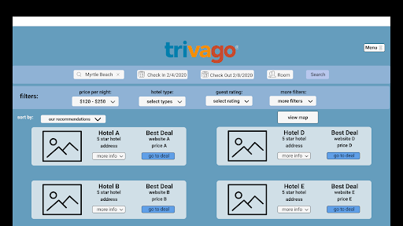

Our third major problem from the heuristic evaluations was the hotel detail panel overlapping with the next hotel below it. Since the detail panel was covering an option, a participant expressed that this could prevent them from selecting that hotel, even if it was the best choice. As you can see in *Figure 3.4*, we solved this issue by moving the next hotel card lower when the user opens a detail panel. This way, no information is hidden from the user, and they can make an informed decision.

*Figure 3.4 Our prototype with Hotel Details Panel open*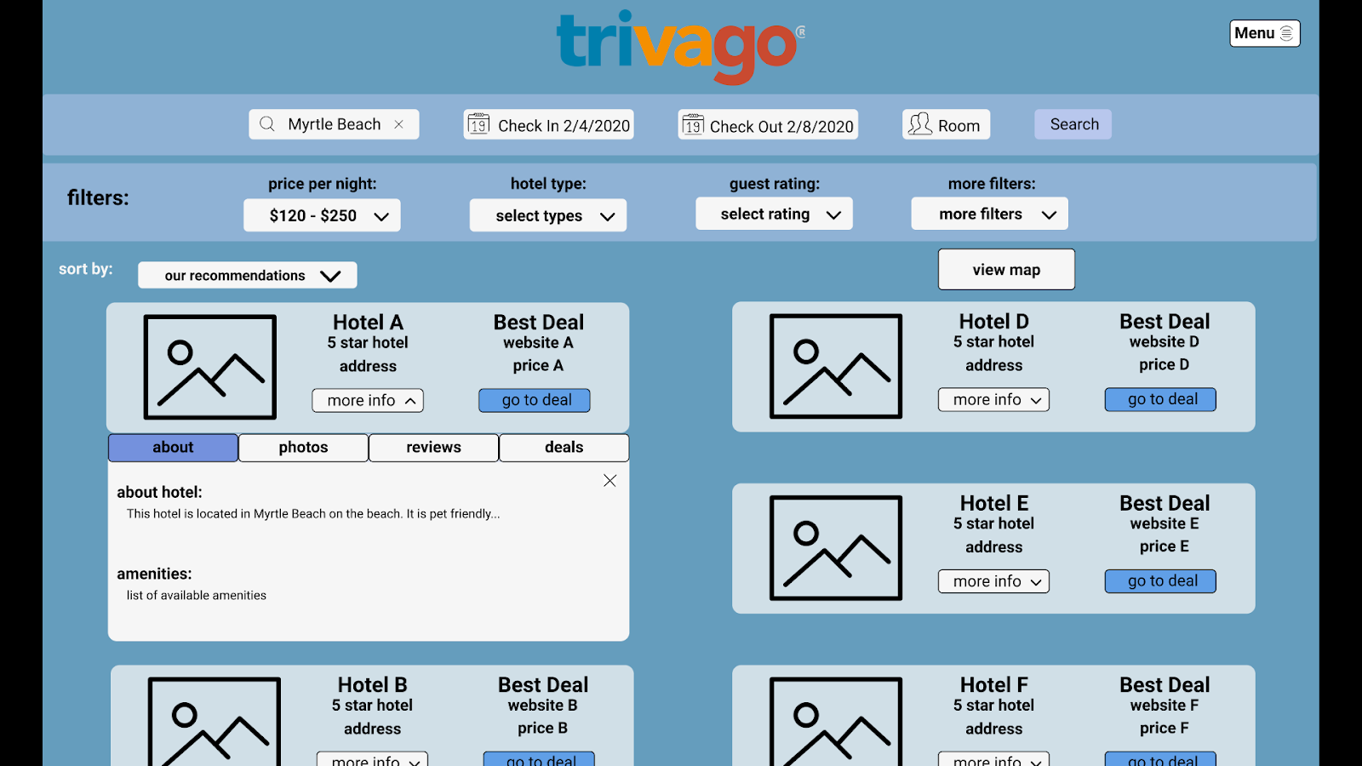

Overall, the heuristic evaluations helped us tremendously for improving our design and prototype of Trivago. We were able to further understand the user’s point of view and goals when using a website like Trivago.

1. Interpreting the Card Sorting Results (Jack)

Our card sorting was an evaluation method we implemented in order to find the best way to organize all of the search filters of Trivago. We had an open card sorting method which gave us many variations of filter groupings.We implemented this method by writing all of the search filters individually on index cards and then ask participants to sort them into groups based upon their similarities. Once completed we then provided them with blank index cards and asked them to name each group that they created.

Eight participants were able to contribute to our card sorting method and provided plenty of quality data. People’s preferences on whether they want a few groupings with many filters in each or many groupings with a few filters in each were the key difference in each card sorting result. User groupings ranged from as different as 7 total filter groups to 3 total filter groups out of the nearly 50 hotel filters. Here is an example: different participants with the same set of cards separated the groups as “Your hotel includes, Type of Hotel, Facilities, Stuff to do” and “Exercise Related, Food Related, Hotel Features, What is in the room.” Even without looking at the cards inside each group, you can tell these are two completely independent ways to organize the same hotel filters. This is the reason we chose card sorting; it narrowed the most common groupings found from each of the infinitely varying results that we could not understand when thinking from the developers perspective.

Once we finalized the results, we realized the open card sorting proved to be the most fruitful part of this evaluation method. This provided the best feedback on how to best organize our names of filter groups. The most common titles such as “Type of Hotel” “Hotel Amenities,” “Rest & Relaxation,” and “Recreation” were found to be the most informative when organizing filters. These all made it into our final product’s filter types.

1. **Conclusion**

In conclusion, We have learned a lot from the process of totally redesigning Trivago. Every step of the process from utilizing evaluation methods to designing the prototype helped us gain knowledge and experience on how to design a product that is more beneficial for human users. The project also taught us how to effectively work in a team. All of the things that we gained from this project are crucially important in the human-computer interaction field and will benefit us in our professional endeavors once we graduate college in the near future.

References

Davis, F. D. (1989). Perceived Usefulness, Perceived Ease of Use, and User

Acceptance of Information Technology. *MIS Quarterly*, *13*(3), 319–340. doi: 10.2307/249008

Osborne, T. (2018, April 2). Color Contrast for Better Readability: Viget. Retrieved from

https://www.viget.com/articles/color-contrast/.

#659dbd Color Hex. (n.d.).

Retrieved from https://www.color-hex.com/color/659dbd.